***Introduction to database***

To create database

Create databasename;

Ex: create league;

To create table

Create table tablename { field or attribute 123..}

EX: create team1{ position , character, players,finance}

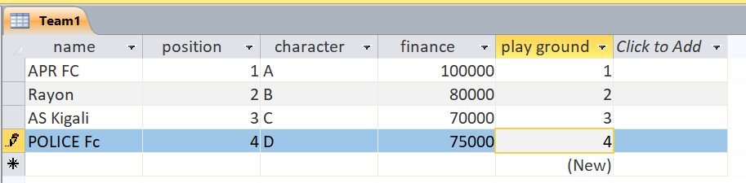

-----------------------------------------------------------------------------------------------------------------------

**This is table design below**

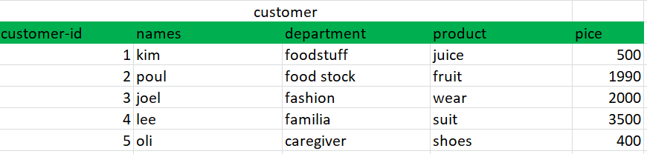

-----------------------------------------------------------------------------------------------------------------------

Now we are going to select raw from our table we use this commond:

-------------------------------------------------------------------------------------------------------------------------------------

**SELECT * FROM customer WHERE price = 2000;**

**SELECT ALL FROM customer WHERE price =2000;**



**--------------------------------------------------------------------------------------------------------------**

**SELECT names FROM customer;**

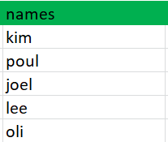

--------------------------------------------------------------------------------------------------------------------------

**SELECT * FROM customer WHERE price > 500;**

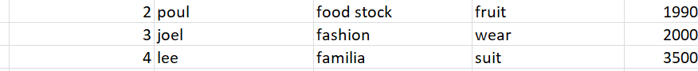

-----------------------------------------------------------------------------------------------------------------------------------------

**SELECT product, price FROM customer;**

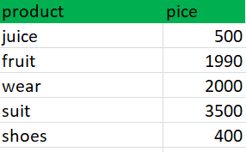

***Introduction to database***

To create database

Create databasename;

Ex: create league;

To create table

Create table tablename { field or attribute 123..}

EX: create team1{ position , character, players,finance}



-----------------------------------------------------------------------------------------------------------------------

**This is table design below**



-----------------------------------------------------------------------------------------------------------------------

Now we are going to select raw from our table we use this commond:

-------------------------------------------------------------------------------------------------------------------------------------

**SELECT * FROM customer WHERE price = 2000;**

**SELECT ALL FROM customer WHERE price =2000;**



**--------------------------------------------------------------------------------------------------------------**

**SELECT names FROM customer;**



--------------------------------------------------------------------------------------------------------------------------

**SELECT * FROM customer WHERE price > 500;**



-----------------------------------------------------------------------------------------------------------------------------------------

**SELECT product, price FROM customer;**



U can develop database by using Microsoft office as shown below

